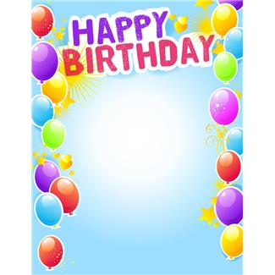

Celebration of birthdays at Håland skole SFO

- We make laminated balloons names, birthdaygreetings, dates and stickers
- If the birthdaychild wants to, he/she can stand on a chair
- The birthdaychild chooses a birthdaysong in Norwegian or English
- The children sing the birthdaysong while the balloons are being handed out
- After the birthdaysong is finished there is a round of applause

- The last Friday in each month is a special day on which we celebrate all
- the children who had their birthday that month
- They all have a joint hot meal
- There is an extra enjoyment of fruit, popcorn, saft and a film this day

